K. R. G.
LEBANESE FRENCH UNIVERSITY
COLAGE OF HEALTH SCIENCE
DEPARTMENT OF MEDICAL LABORATORY SCIENCE

Evaluating the Impact of Smoking on Blood Incidence and Hypertension Risk in Erbil City"

A Graduation Project Submitted to Department of Medical laboratory science /College of Health science. In Partial Fulfillment of the Requirements for the Degree of Bachelor of Science in Medical laboratory science

PREPARED BY
Yosif Arif Muhammed
Zhina Muhammed Tahir
Nazan Ghanim Darweesh
Nabila Ahmad Omar
Helin Ary Xurshed
SUPERVISOR
Asst.lec.Muzha Hayder Saber

HAWLER-2025

ACCEPTANCE and APPROVAL PAGE

This thesis entitled assessing the effects of smoking on blood parameters and hypertension risk in hawler city presented by Yousif Arif Muhammed, Zhina Muhammed Tahir, Nazan Ghanim Darwesh, Nabila Ahmad Omar, Helin Ary Xurshed under supervision of Ass.lec.Muzhda Hayder Saber in the department of Medical Laboratory Science has been accepted as a B. Sc. Research project according to Legislations of Graduate Higher Education on …..../......./.......... with unanimity / majority of votes members of jury.

Chair:.......................................... | Signature:
Member:...................................... | Signature:
Member:...................................... | Signature:
Member:...................................... | Signature:
Member: ...................................... | Signature:

This thesis has been approved by the committee of The collage of Health Science on ..……../.........../…...…...

Signature
……………..………..
Dean of Health Science

THESIS STATEMENT

All information presented in the thesis obtained in the frame of ethical behavior and academic rules. In addition, all kinds of information that does not belong to me have been cited appropriately in the thesis prepared by the thesis writing rules.

(Signature)
(Name, Last name)

ABSTRACT

ASSESSING THE EFFECTS OF SMOKING ON BLOOD PARAMETERS AND HYPERTENSION RISK IN HAWLER CITY

BSc. Research project medical laboratory science
Supervisor : Ass.Lec.Muzhda Hayder Saber
May 2025, 46 pages

Background: Smoking poses significant health risks, yet its impact on hematological parameters and hypertension in the Kurdistan region remains underexplored. This cross-sectional study investigates the relationship between smoking habits, blood parameters, and cardiovascular health among adults in Hawler city, Iraq.
Methods: A total of 167 participants (112 smokers, 55 non-smokers) aged 18-70 were recruited. Comprehensive data collection included demographic information, anthropometric measurements, blood pressure assessments, and hematological parameter analysis. Participants underwent venipuncture for complete blood count analysis using an automated hematology analyzer. Statistical analysis employed t-tests, chi-square tests, correlation analyses, and risk ratio calculations.
Results: Smokers demonstrated significantly altered hematological profiles compared to non-smokers, with notably elevated red blood cell count (+27.2%), hemoglobin (+12.9%), and hematocrit (+11.9%). Hypertension prevalence was substantially higher among smokers (58.0%) versus non-smokers (38.2%), with a risk ratio of 1.52 and odds ratio of 2.24. Smoking duration showed a dose-response relationship, with individuals smoking over 20 years exhibiting the highest hypertension rate (90.9%).
Conclusion: The study reveals significant associations between smoking and hematological alterations and increased hypertension risk. These findings underscore the critical need for targeted public health interventions and smoking cessation programs in the Kurdish population.

Keywords: Smoking, Hematological Parameters, Hypertension, Kurdistan, Blood Pressure

ACKNOWLEDGMENT

In the name of Allah, the Infinitely Gracious, the Most Merciful. We are deeply grateful for His kindness and support, which enabled us to complete this research. We would like to sincerely thank our supervisor, (Asst.Lect.Muzhda H.Saber), for her continuous guidance, valuable advice, and unwavering support from the very beginning to the conclusion of this study. We extend our sincere thanks to our families for their unconditional emotional and financial support, always standing by us in all circumstances. We are also thankful to our university, LFU - including all staff members and students - for their encouragement and contributions to our research. Special thanks are due to the Head of Department, Our heartfelt appreciation also goes to Head of department (Lect.Zanko H.Jawhar), for his consistent support at every stage. and will always be remembered. (Dr. Hemin Abdullaziz) for his patience in addressing every question we had and for his step-by-step guidance throughout the process of developing our thesis.Finally, we thank you for taking the time to read our study. We would like to acknowledge Mrs.Lab Assistant Sana Sherdl for her persistent assistance whenever we needed help, as well as all our colleagues at various levels for their support in completing this study. Our deep gratitude also goes to Dalany and Master Gen Laboratory for their essential assistance with the practical component of our study, offering their valuable time and financial support by reducing the cost of the tests. Their generosity and humanity are sincerely appreciated We hope this research helps to demonstrate the severe harm that any form of smoking can inflict upon the human body.

2024
Yousif KAINJI

Table of Contents

ABSTRACT i
ACKNOWLEDGMENT iii
1. Introduction 1
2. Literature Review 3
3. Materials and methods 12
3.1 Study Design and Setting 12
3.2 Population study 12
3.3 Data collection: questionnaire 12
3.4 Body Measurements 13
3.5 Blood Pressure Check 13
3.6 Blood Draw and Analysis 13
3.7 A statistical analysis 14
4. Result 14
4.1 Key findings include: 14
4.2 Descriptive Statistics 15
4.3 Smoking Analysis 16
4.4 Comparative Analysis: Hematological Parameters 17
4.5 Blood Pressure and Hypertension Analysis 18
4.6 Correlation Analysis 19
4.7 Impact of Different Smoking Types Smoking Types Distribution 20
5. DISCUSSION 25
5.1 Altered Hematological Parameters in Smokers 26
5.2 Smoking and Hypertension Risk 26
5.3 Correlation Analysis and Clinical Implications 27
6. Conclusion 28
7. Recommendations 29
7.1 Clinical Practice Recommendations: 29
7.2 Public Health Recommendations: 29
7.3 Research Recommendations 30
8. REFERENCES 31

LIST OF TABELS

Table 1 Shows Key Numerical Variables 15
Table 2 Age and BMI Comparison Between Smokers and Non-Smokers 17
Table 3 Comparison Between Smokers and Non-Smokers 17
Table 4 Blood Pressure Comparison 18
Table 5 Hypertension Risk Analysis 18
Table 6 Hypertension by Smoking Duration 19
Table 7 Correlation Between Smoking Duration and Parameters 19
Table 8 Hypertension Rates by Smoking Type 21

LIST OF FIGURES

Figure 1 Shows Blood Pressure Categories: Smokers vs Non-Smokers 21
Figure 2 Shows Hematological Parameters: Smokers vs Non-Smokers. 22
Figure 3 Shows Blood Pressure by Smoking Duration. 23
Figure 4 Shows the RBC Count by Smoking Duration 24
Figure 5 Shows the Hemoglobin by Smoking Duration. 24
Figure 6 Shows the Platelet Count by Smoking Duration. 25

Introduction

The health effects of tobacco consumption, especially with regard to hematological parameters and risk of hypertension, have received considerable focus within the past decade, especially in the Kurdistan region of Iraq. This literature review combines the results of different studies by pointing to the complex interplay between smoking habits and resulting health effects in adolescents and adults residing within this area(Siziya et al., 2007). who examined the predictors of cigarette smoking among adolescent school students in the Kurdistan region. According to their paper, it was noted that the Ministry of Health has devoted great attention to tobacco control programs; however, limitations related to the sample and reliance on self-reported data may undermine the generalizability of the results. This fundamental study emphasizes the importance of determining the environmental and social determinants of smoking behavior in teenagers that are critical in creating successful public health interventions(Hussain and Abdul Satar, 2013). estimated the prevalence of tobacco use and determinants of tobacco use among Iraqi youth through the Kurdistan-Iraq Global Youth Tobacco Survey. The findings showed extensive smoking, particularly among males, and indicated the role of peer group and financial factors. The research underscores the urgent necessity for targeted programs to curtail tobacco consumption among this susceptible population, particularly in light of the general health concerns related to smoking in developing countries(Kadhum et al., 2014). expanded the debate by examining the acute cardiovascular effects of cigarette smoking and establishing a definite connection between smoking and elevated blood pressure. Their paper presents a physiological dimension to theorizing health risks of smoking, hypothesizing that initial cardiovascular responses to smoking can have long-term implications for hypertension. The waterpipe smoking prevalence(Othman et al., 2017), introduces yet another aspect of the tobacco use model in Iraqi Kurdistan. As observed from their research, waterpipe smoking is very prevalent among university students, a shift in the pattern of tobacco consumption. This growing popularity introduces even more public health issues, as waterpipe smoking is perceived as less harmful, though it has severe health implications(Mehboudi et al., 2017), studied the reverse association of smoking and hypertension in an older Iranian cohort, speculating that smoking may have complex and situation-dependent effects on blood pressure. Such a finding indicates the importance of placing more research on the various impacts of smoking on various groups of people and types of diseases(Restuti and Suryana, 2018). conducted research into the effects of cigarette smoking on hematological parameters, which identified a significant difference in smokers compared to non-smokers. Their findings offer important insight into the effect of smoking on the blood composition that is essential to understanding the broader health implications of tobacco consumption. Furthermore(Andriani et al., 2020), extended the argument through investigation into the long-term effects of smoking on blood pressure in a heterogeneous population. Their findings confirm the evidence of smoking being related to hypertension as evidenced from documentation, that stopping smoking may increase blood pressure values, hence reinforcing the requirement for smoking cessation intervention. In the end(Shakiba et al., 2023), introduced a contemporary investigation into tobacco smoking's impacts on blood indicators in the Iranian Kurdish population. The study highlights the association of smoking intensity with different hematological factors, such as the number of red blood cells and hemoglobin levels, while also calling for greater research on the impact of passive smoking. The aim of this study is to assess the effects of smoking on hematological parameters and hypertension risk in adults in Hawler city, Kurdistan region-Iraq, to elucidate the physiological mechanisms underlying smoking-induced cardiovascular changes and to generate evidence-based data that may guide local public health policy and clinical practice guidelines for smoking-related health risks.

AIMS
Principal Objectives
1-To investigate the correlation between smoking behavior and hematological parameters - (RBC, Hb, HCT, MCV, MCH, MCHC, RDW, Plt, MPV, WBC) in people residing in Hawler city, Kurdistan region-Iraq.
2-To evaluate and determine the relationship of smoking status and risk for hypertension in the study population.
Secondary Objectives
1- To examine the relationship between the duration of smoking and hematological marker changes and blood pressure readings by dose-response analysis.
2- To evaluate the impact of various modes of smoking (cigarette, hookah, vape) on hematological parameters and hypertension risk.
3- To examine the association between smoking duration and certain hematological parameters that may serve as potential biomarkers for cardiovascular risk of smoking.
4- In order to assess if age and BMI affect the interaction between smoking status and hematological variables and hypertension.
5- To create a baseline database of smoking-related hematological and cardiovascular alterations in the Kurdish population for evidence-based local public health policy and therapeutic strategies.

Literature Review

The article "Correlates of Current Cigarette Smoking Among In-School Adolescents in the Kurdistan Region of Iraq"(Siziya et al., 2007) offers useful data on adolescent smoking behavior in the Kurdistan region, which indirectly can direct the research of smoking influence on hematological parameters and risk of hypertension. The authors point to enforcement of a lot of the initiatives for preventing tobacco, understanding tobacco control to be a ministry priority. Such a background scenario is required because it is one of official acknowledgment of the hazards on health which occur due to the use of tobacco, potentially involving hematologic health and cardiovascular concerns, i.e., high blood pressure. One of the greatest weaknesses of the study is its use of self-reported data from teenagers, raising concerns about the validity of the data collected.
Self-reporting may result in underreporting and overreporting of smoking habits, hence distorting the prevalence statistics of smoking among teenagers. This constraint is crucial in estimating the general consequences of smoking for health outcomes, as the validity of the information directly affects comprehension of smoking's impact on hematological parameters and hypertension. The authors examine the effect of several individual-level characteristics, including religion, alcohol use, and sibling smoking status, on teen smoking behavior. These factors may serve as surrogates for the determination of the environmental and social determinants of smoking that can also correlate with health outcomes such as hypertension. Adolescent smokers may have lifestyle choices contributing to increased blood pressure or abnormal blood values warranting further research to investigate such correlations. The reference to tobacco smuggling as a source of smokes for youth highlights the complexity of tobacco control in the area.
Ongoing violence in Iraq may worsen these complications, potentially raising the availability and acceptability of smoking among young people. The authors promote evidence-based public health interventions, requiring constant research to assess how successful these activities are in curbing smoking rates and consequently reducing health problems caused by tobacco use. The article "Prevalence and Determinants of Tobacco Use Among Iraqi Adolescents: Iraq GYTS 2012"(Hussain and Abdul Satar, 2013) presents a critical evaluation of the use of tobacco among adolescents in Iraq with the focus placed on the dire public health matters of this demographic. The writers bring attention to the fact that teenagers are one very vulnerable population to health-oriented activities, of which the experiment of tobacco usage is remarkably common. Such behavior poses serious health risks, especially in underdeveloped countries like Iraq. The article reveals that the rate of current cigarette smoking among Iraqi teenagers is 15.3%. The figure highlights the urgency of dealing with tobacco use in the region, especially in light of the fact that tobacco use trend has been moving away from the developed world and into the developing nations, including the Middle East.
Authors imply that greater access and social acceptability of tobacco among teenagers could be a contributory factor for the rising trend of smoking. The research reveals several factors concerning teenager tobacco consumption. Smoking by parents and peers, male gender, and having more pocket money have strong impacts. The authors contend that these variables create an environment where tobacco smoking is normative and accepted as something desirable, especially in young boys. This social process is important in explaining the tobacco epidemic in Iraq because it captures larger social forces that have the potential to sustain smoking habits. Moreover, the research highlights the absence of proper documentation of tobacco smoking prevalence in Iraq, especially in areas impacted by long-term hostilities and sanctions. The absence of adequate data inhibits public health activities to prevent tobacco use and alleviate its related health problems. The authors encourage intensive research towards enhancing knowledge related to tobacco usage behavior and relevant variables that have an impact on the same behavior within various environments of Iraq. The article "Measuring the Acute Cardiovascular Effects of Shisha Smoking: A Cross-Sectional Study"(Kadhum et al., 2014) is full of significant information regarding the cardiovascular effects of smoking, in this instance, shisha smoking, which is common in different parts of the world, for example, the Kurdistan region of Iraq. The authors cite the relationship between smoking and heightened sympathetic output, an important consideration in the causation of cardiovascular diseases. The research carefully examines the acute effects of shisha smoking on cardiovascular parameters, and these effects are extrapolatable for understanding the wide-ranging effects of smoking on hematological parameters and risk of hypertension.
The research indicates that smoking is capable of inducing acute cardiovascular effects like tachycardia and rise in blood pressure, which are critical indicators of cardiovascular well-being.
Such spontaneous response is highly applicable in view of the heightened trend in smoking in urban places like Hawler where lifestyle aspects worsen conditions. Furthermore, the authors investigate the pathophysiological mechanisms whereby smoking worsens cardiovascular conditions. The findings reveal that increased sympathetic outflow owing to nicotine intake can result in chronic hypertension and other deleterious hematological alterations. This is consonant with current research on the negative impact of smoking on vascular function and blood composition that could contribute to higher risks of hypertension and the associated diseases. While the paper heavily leans towards the cardiovascular effects of shisha smoking, it also urges more research to examine the long-term implications of such smoking habits. The cross-sectional design of the study constrains causality and long-term health outcomes from being concluded in certain respects. Longitudinal study designs in future studies can evaluate the long-term impact of smoking on hematologic parameters and hypertension over time. The article "Waterpipe Smoking among University Students in Sulaimaniyah, Iraqi Kurdistan: Prevalence, Attitudes, and Associated Factors"(Othman et al., 2017) presents a detailed analysis of the prevalence and attitudes towards waterpipe smoking among university students in Iraqi Kurdistan. A key implication of the study is the public health issue, especially against the backdrop of high levels of tobacco use in this group.
Cross-sectional survey design involved 1,160 Sulaimani Polytechnic University students who responded to a self-reported questionnaire. From the data, it was evident that 28% of the students who were surveyed smoked waterpipe, with significantly higher prevalence among men (49%) than girls (10%). Such gender differential is an indication of the need for targeted public health interventions, especially since 74% begin waterpipe smoking prior to university.
Also, the research indicates that the coffee house is the most frequent setting for waterpipe smoking (52%), showing that there is a social aspect to this behavior that may contribute to its popularity. Pipe-sharing practice (71% among waterpipe smokers) multiplies public health concerns, as it may enhance infectious disease transmission beyond the health damage from smoking tobacco.
The authors advocate for the need for age-specific tobacco control interventions among youth and adolescents, in light of the rising social acceptability of waterpipe smoking. This statement is consistent with the growing evidence that suggests early intervention can prevent long-term health consequences related to tobacco use.
The paper "Inverse association between cigarette and water pipe smoking and hypertension in an elderly population in Iran: Bushehr elderly health programme"(Mehboudi et al., 2017) provides strong evidence that adds to the debate on smoking and hypertension, in this case, for an elderly population in Iran. The study defies conventional understanding of the relationship between smoking and hypertension, suggesting an inverse relationship that needs further exploration.
The authors used a large-scale study based on the Bushehr older Health Programme data, which included a large population of older people. Their study included comprehensive assessments of smoking status, blood pressure, and other hematological variables. This comprehensive strategy enables comprehensive analysis of the relationship between smoking—cigarette and water pipe—and hypertension risk in older people.
The research illustrates a possible protective effect of smoking against hypertension in the cohort studied. This is a significant discovery given the general assumption that smoking also increases cardiovascular risk equally. The authors offer many hypotheses to account for this paradox, including the vasodilatory effect of nicotine and social and lifestyle factors linked with smoking on reduced blood pressure in this group.
But while the study findings are compelling, they need rigorous examination as well. The authors recognize the limitation of this study, particularly the cross-sectional design, and that it constrains causal inference. The use of self-report of smoking status may be a source of bias because respondents might underreport or misreport their smoking status. These measures reinforce the need for longitudinal studies in further exploring the complexity of smoking habit and its health impact.
Moreover, the article stresses the need for acknowledging regional disparities in smoking behavior and health consequences. The situation within Hawler city in the Kurdistan region of Iraq may largely vary from that of the studied subjects in Iran, so that the results may not be directly transposed. In the future, it should aim to investigate such associations specifically within the Kurdish people, i.e., cultural, environmental, and genetic determinants that may affect both smoking habit and risk of hypertension.
The paper "Protein Intake and Hematological Parameters in Smokers"(Restuti and Suryana, 2018) offers a comprehensive discussion of cigarette smoking's impact on hematological parameters, with special focus on comparisons between male smokers and non-smokers. The authors provide a clear description of how smoking impacts different constituents of blood, an essential aspect of comprehending the larger health effects of smoking, especially concerning disorders like hypertension.
The research indicates that cigarette smoking substantially changes hematological values, such as hemoglobin concentration, red blood cell count, and other essential indices of blood. This change is more pronounced when comparing smokers and non-smokers, an indication that smoking not only impacts the immediate physiological condition but may have potential long-term health consequences. The authors present a comparative analysis that considers these differences, which is essential in understanding the influence of smoking in health risk, such as hypertension.
The study examines the relationship between smoking and biochemical markers in explaining how alterations in hematological parameters are correlated with higher risk of cardiovascular disease, especially hypertension. The authors effectively correlate the pathophysiological alterations caused by smoking to possible clinical implications, emphasizing the significance of public health interventions to decrease smoking prevalence.
The critical analysis of the content demonstrates that the article, though thorough in its research, would be improved with a larger demographic population coverage of female smokers and non-smokers alongside male smokers. This would provide an overall impression in terms of the effect of smoking on hematological parameters in various populations. The article may also explore the mechanisms through which smoking influences blood parameters, thus furthering the knowledge of the pathophysiological mechanisms involved.
The research "Effects of Changes in Smoking Status on Blood Pressure Among Adult Males and Females in Indonesia: A 15-Year Population-Based Cohort Study"(Andriani et al., 2020) presents an in-depth discussion of the connection between smoking status and long-term changes in blood pressure. The research is specifically of relevance in elucidating the extensive effects of smoking on cardiovascular disease, predominantly hypertension, a significant condition across diverse populations like the people of the Kurdistan region of Iraq.
The authors utilize a strict longitudinal design, following a diverse population over 15 years, hence reinforcing the strength of evidence. Changes in smoking status—new, cessation, or ongoing use—substantially influence levels of blood pressure. This concurs with the rest of the research discussed in the article which identifies the relationship between smoking and hypertension risk, including the(Morford et al., 2011) which established a direct relationship between smoking and high blood pressure among men and women.
Among the key observations of(Andriani et al., 2020) is the contrast in the effects of smoking quit on blood pressure, where those quitting smoking experience quite a mitigation in hypertension risk in the course of time. Such observations have been supported (Lee et al., 2001) where quitting was proved to result in the realization of tremendous improvements in blood pressure level. The article emphasizes the significance of demographic variables, i.e., body mass index (BMI), when quantifying the impact of smoking on blood pressure, as proven (Qin et al., 2010)in their research on the Mongolian population.
But with regard to the study findings, albeit informative, it is also essential to acknowledge the limitations in population-based studies, including possible confounding variables and self-reported smoking status, which may exert bias. Furthermore, the various cultural and environmental settings in Indonesia may not exactly replicate settings in Hawler, Kurdistan, where socio-economic determinants and access to healthcare could be quite different.
The research article "Tobacco Smoking and Blood Parameters in the Kurdish Population of Iran(Shakiba et al., 2023)is a wide-ranging review of how smoking connects to hematologic parameters within one particular population base. The research is built upon baseline data drawn from the Ravansar Non-Communicable Disease cohort study, enhancing its accuracy by an ordered method of subject recruitment and data collection.
The research establishes a positive correlation between smoking history and intensity with the majority of blood parameters like red blood cells, hematocrit, hemoglobin, mean corpuscular volume, and mean corpuscular hemoglobin. This correlation indicates that smoking may exert considerable physiological changes that may lead to changes in hematological profiles. The authors emphasize that although previous research has demonstrated such patterns, a vast lack of data exists regarding these effects in the Iranian population, thus pointing towards the significance of the study in bridging the gap.
Division of participants into five categories of smoking status—current smokers, former smokers, non-smokers, and passive smokers—gives an extensive idea of the influence of smoking behaviors on blood parameters. The researchers document that passive smokers, especially women secondhand smokers, displayed increased susceptibility to the adverse effects of tobacco smoke. This discovery emphasizes the importance of public health interventions for the protection of non-smokers, particularly children and women, against the hazards of secondhand smoke exposure. The study design, which employs the National Health Insurance Scheme to examine smoking behavior and demands informed consent, demonstrates high ethical standards and scientific integrity. The study would be improved with a more detailed examination of how smoking affects hematological markers, including the mechanism by which the effects are achieved. The article demonstrates an association but fails to explain the biological mechanism for the association, which might make the observed effects more understandable. Moreover, given the relevance of the paper, it can enhance its significance by including a discussion of implications of these results for hypertension risk because correlation between hematological changes and blood pressure is a significant field of study. Knowledge about correlation between smoking changes in blood and development of hypertension could potentially lead to significant recommendations for public health policies aimed at lowering smoking-caused health risks among the Kurdish people. The research on the effects of the hematological parameters of smoking and hypertension risk in Iraq's Kurdistan region gives an overview of tobacco use's impacts on health. The articles being discussed collectively underscore the prevalence of smoking, especially among youth and adolescents, as well as the linked health dangers, including hematological alterations and hypertension. The path-breaking study by(Siziya et al., 2007) accounts for adolescent smoking behavior and identifies social and environmental determinants as the influence. The study shows that tobacco control is the focus of the Ministry of Health; however, the use of self-reported measures poses doubts regarding the validity of smoking prevalence rates(Hussain and Abdul Satar, 2013). points out the high rate of smoking among Iraqi teenagers, especially among boys, and cites peer pressure and socioeconomic status as major determinants. The results indicate that some public health interventions are required to counteract tobacco use among this vulnerable population. Research such as(Kadhum et al., 2014) also examines the physiological effects of smoking, demonstrating the clear link between smoking and acute cardiovascular consequences, including increased blood pressure. The link is central to the study of the long-term dangers of hypertension associated with smoking behavior. In addition(Restuti and Suryana, 2018), expounds the impact of smoking on haematological parameters since they have demonstrated significant differences in blood content between smokers and non-smokers that is important for determining overall health risk. This prevalence of waterpipe smoking, as noted by(Othman et al., 2017). complicates the smoking dynamics in the region, especially among university students. This phenomenon requires targeted public health interventions to counteract the desensitization to waterpipe consumption as less harmful. The study by(Mehboudi et al., 2017). that found an inverse association between smoking and hypertension implies that smoking can have context-dependent effects, and hence it is essential to explore its complex effects on various populations. The long-term consequence of smoking on blood pressure is corroborated by(Andriani et al., 2020), which indicates that smoking cessation may alleviate blood pressure outcomes, thus highlighting the relevance of successful cessation programs. Essentially, (Shakiba et al., 2023) refers to the implication of the prevalence of smoking towards harmful blood parameter alterations among the Kurdish population, referring to increased further research into direct as well as indirect implications on their health by smoking. Consistently, as outlined below, this literary review establishes that this relationship has had complex involvement across Kurdistan region in the Iraqi context. The research as a whole highlights the imperative need for comprehensive public health interventions that address smoking and its associated health concerns, especially among teenagers and vulnerable groups. Further study and focused interventions need to be directed toward lessening the health effects of smoking tobacco in this region.
The aim of this study is to evaluate the impact of smoking on hematological indices and risk of hypertension among the adult residents of Hawler city, Kurdistan region-Iraq, in order to gain better knowledge of the physiological mechanisms behind smoking-induced cardiovascular changes and to provide evidence-based information that can be utilized in local public health policies and clinical practices to control smoking-associated health risks.

Materials and methods

Study Design and Setting
In Hawler, Kurdistan Region, Iraq, the Lebanese French University performed this cross-sectional research. Pirmam City, Hawler Government, collected data from December 2024 to February 2025. The Lebanese French University College of Health Science Research Ethics Committee accepted the research (HCS-2023-127).

Population study
We recruited 167 people aged 18–70 (112 smokers and 55 non-smokers) via casual sampling. To represent smokers and non-smokers, participants were chosen by smoking status. The study included participants aged 18+ who gave informed permission. Hematological problems, infection, cancer, pregnancy, and drugs that impact hematology were excluded.

Data collection: questionnaire
A standardized questionnaire was given to all participants to gather demographic data (age, gender, education level).
• Anthropometric measures (height, weight)
• Medical background (chronic conditions, medication use)
• Smoking behaviors (status, duration, kind, frequency)
Smokers were given specific information about:
• Type of smoking (cigarette, hookah, vape, etc.) • Duration of smoking (years)
• Average cigarette/session count daily/weekly • Age of smoking commencement

Body Measurements
Standard weight and height measurements were taken. Participants wore light clothes and no shoes and were weighed to the closest 0.1 kg on a calibrated digital scale (Seca Model 769, Hamburg, Germany). A stadiometer (Seca Model 213, Hamburg, Germany) measured height to 0.1 cm. BMI was computed by dividing weight (kg) by height squared (m²).

Blood Pressure Check
After sitting for at least 5 minutes, a calibrated digital sphygmomanometer (Omron M3, Omron Healthcare Co., Ltd., Kyoto, Japan) assessed blood pressure. The average of two 2-minute readings was collected. Participants were categorized by 2017 ACC/AHA guidelines: normal (<120/80 mmHg), raised (120-129/<80), stage 1 hypertension (130-139/80-89), stage 2 hypertension (≥140/90), and hypertensive crisis (>180/120 mmHg).

Blood Draw and Analysis
Standard venipuncture was used to collect 5 mL of blood from each participant following an overnight fast (8-12 hours). EDTA tubes were used to collect blood for CBC analysis.Samples were examined within 4 hours.
At the Medical Laboratory Science Department, Lebanese French University, an automated hematology analyzer (Sysmex XN-1000, Sysmex Corporation, Kobe, Japan) assessed hematological parameters.
The following parameters were evaluated:
• RBC count
• Hb concentration :Measurements include HCT, MCV, MCH, and MCHC.
• Red Cell Distribution Width (RDW)
Measurements include Plt count, MPV, and WBC count.
Daily quality control was done following manufacturer directions to guarantee results correctness and dependability.

A statistical analysis
Data were analyzed using IBM SPSS Statistics 26.0 (IBM Corp., Armonk, NY, USA). Means, standard deviations, medians, and ranges for continuous variables and frequencies and percentages for categorical variables were used for descriptive statistics.
Samples independently Smokers and non-smokers were compared hematologically using t-test. Smoking status and hypertension were examined using chi-square test. Smoking duration was correlated with several indicators using Pearson correlation analysis. Smoking was linked to hypertension using risk ratio (RR) and odds ratio (OR).
One-way ANOVA with post-hoc Tukey test was used to evaluate parameters across smoking duration (0-5 years, 6-10 years, 11-20 years, >20 years) and type (cigarette, hookah, vape). Multiple regression was used to account for age and BMI. All analyses were judged significant with a p-value <0.05.
The SPSS version was used to construct bar charts and line graphs to depict smoking status, hematological parameters, and blood pressure.

Result

This analysis investigates the relationship between smoking habits, hematological parameters, and hypertension risk based on data collected from 167 participants in Hawler city, Kurdistan region-Iraq. The dataset consists of 112 smokers and 55 non-smokers, providing valuable insights into how smoking affects blood parameters and cardiovascular health.

Key findings include:

Significantly higher hematological values in smokers: Smokers exhibited notably elevated levels of RBC, Hb, and HCT compared to non-smokers.

Increased hypertension risk: Smokers showed a higher prevalence of hypertension (58.0%) compared to non-smokers (38.2%).

Smoking type variations: Different smoking methods (cigarettes, hookah, vape) showed varying impacts on blood parameters.

Duration effects: Longer smoking duration correlated with increased hypertension risk, with those smoking for >20 years showing the highest rates (90.9%).

4.2 Descriptive Statistics

Sample Characteristics
- Total participants: 167
- Smokers: 112 (67.1%)
- Non-smokers: 55 (32.9%)
- Age range: 18-70 years (Mean: 32.1)
- BMI range: 17-41 (Mean: 26.4)

Table 1 Shows Key Numerical Variables
Variable | N | Min | Max | Mean | Median | Std. Dev
Age (Years) | 165 | 18 | 70 | 32.1 | 27 | 13.3
BMI | 165 | 17 | 41 | 26.4 | 25.7 | 5.0
RBC | 165 | 3.71 | 84 | 5.7 | 5.33 | 6.1
Hb | 165 | 9.7 | 18.4 | 15.0 | 15.5 | 1.8
HCT | 165 | 25.4 | 56 | 45.0 | 46.5 | 5.7
MCV | 165 | 60.5 | 96.8 | 85.9 | 86.7 | 5.5
MCH | 165 | 18.9 | 33.5 | 28.7 | 28.9 | 2.1
MCHC | 165 | 30.6 | 38.6 | 33.5 | 32.9 | 1.9
RDW% | 165 | 10.6 | 14.8 | 11.9 | 11.8 | 0.8
Plt | 165 | 77 | 346 | 234.8 | 235 | 49.5
MPV | 165 | 7.1 | 13.9 | 10.4 | 10.3 | 1.3
WBC | 165 | 4.5 | 17.2 | 8.1 | 7.7 | 2.2
Systolic BP | 165 | 90 | 170 | 120.8 | 120 | 13.9
Diastolic BP | 165 | 50 | 130 | 75.2 | 70 | 12.6

Smoking Analysis

Smoking Prevalence and Patterns

- Smoking prevalence: 67.1% of study participants were smokers
- Smoking duration: Ranged from weeks to 40 years, with a mean of approximately 10.2 years among smokers
- Smoking types:
  - Cigarette smokers: 77 (68.8% of smokers)
  - Hookah users: 45 (40.2% of smokers)
  - Vape users: 28 (25.0% of smokers)
  - Multiple types: 30 (26.8% of smokers)
Table 2 Age and BMI Comparison Between Smokers and Non-Smokers
Variable | Smokers (Mean) | Non-Smokers (Mean) | Difference
Age (Years) | 29.4 | 37.5 | -8.1
BMI | 25.8 | 27.5 | -1.6
Note: Smokers in the sample tended to be younger and had slightly lower BMI compared to non-smokers.

Comparative Analysis: Hematological Parameters

Table 3 Comparison Between Smokers and Non-Smokers
Parameter | Smokers (Mean) | Non-Smokers (Mean) | Difference | % Difference
RBC | 6.15 | 4.84 | +1.32 | +27.2%
Hb | 15.59 | 13.81 | +1.78 | +12.9%
HCT | 46.61 | 41.66 | +4.95 | +11.9%
MCV | 85.77 | 86.18 | -0.41 | -0.5%
MCH | 28.78 | 28.63 | +0.15 | +0.5%
MCHC | 33.60 | 33.23 | +0.37 | +1.1%
RDW% | 11.93 | 11.86 | +0.07 | +0.6%
Plt | 228.51 | 247.47 | -18.96 | -7.7%
MPV | 10.41 | 10.40 | +0.01 | +0.1%
WBC | 7.98 | 8.20 | -0.21 | -2.6%

Key Findings:
- Smokers showed significantly higher red blood cell (RBC) count (+27.2%)
- Hemoglobin (Hb) levels were notably higher in smokers (+12.9%)
- Hematocrit (HCT) was considerably elevated in smokers (+11.9%)
- Platelet count (Plt) was lower in smokers (-7.7%)
- Other parameters showed minimal differences between the groups

Blood Pressure and Hypertension Analysis

Table 4 Blood Pressure Comparison
Parameter | Smokers (Mean) | Non-Smokers (Mean) | Difference
Systolic BP | 122.3 | 117.7 | +4.6
Diastolic BP | 75.8 | 74.2 | +1.6

Table 5 Hypertension Risk Analysis
Group | Total | Hypertensive Cases | Percentage
Smokers | 112 | 65 | 58.0%
Non-Smokers | 55 | N 21 | 38.2%

Risk Assessment:
- Risk Ratio: 1.52 (smokers have 1.52 times higher risk of hypertension)
- Odds Ratio: 2.24 (the odds of hypertension are 2.24 times higher in smokers)

Table 6 Hypertension by Smoking Duration
Duration | Count | Hypertensive Cases | Percentage
0-5 years | 37 | 22 | 59.5%
6-10 years | 35 | 22 | 62.9%
11-20 years | 26 | 10 | 38.5%
>20 years | 11 | 10 | 90.9%
Note: The highest hypertension prevalence was observed in long-term smokers (>20 years), while an unexpected lower rate was seen in the 11-20 year group, possibly due to age differences or other confounding factors.

Correlation Analysis

Table 7 Correlation Between Smoking Duration and Parameters
Parameter | Correlation Coefficient
Age (Years) | +0.475
BMI | +0.169
RBC | -0.086
Hb | -0.041
HCT | -0.241
MCV | -0.108
MCH | +0.216
MCHC | +0.393
RDW% | +0.085
Plt | +0.177
MPV | -0.209
WBC | +0.028
Systolic BP | +0.090
Diastolic BP | +0.183
Key Correlations:
- Moderate positive correlation between smoking duration and age (r = 0.475)
- Moderate positive correlation with MCHC (r = 0.393)
- Weak negative correlation with HCT (r = -0.241)
- Weak positive correlation with MCH (r = 0.216)
- Weak negative correlation with MPV (r = -0.209)
- Weak positive correlation with diastolic BP (r = 0.183)

Impact of Different Smoking Types Smoking Types Distribution

- Cigarette Only: 68.8% of smokers
- Hookah Only: 13.4% of smokers
- Vape Only: 6.3% of smokers
- Multiple Types: 26.8% of smokers

Table 8 Hypertension Rates by Smoking Type
Smoking Type | Count | Hypertension Rate
Cigarette | 77 | 63.6%
Hookah | 45 | 53.3%
Vape | 28 | 46.4%
Finding: Cigarette smoking appears to have the strongest association with hypertension compared to hookah or vape use.
This comparative bar chart clearly demonstrates that smokers have higher rates of hypertension compared to non-smokers. Specifically, smokers show double the rate of Stage 1 hypertension (40 vs 20) and Stage 2 hypertension (20 vs 10), and four times the rate of hypertensive crisis (8 vs 2). Meanwhile, non-smokers have higher representation in the normal blood pressure category. This strongly suggests that smoking is associated with increased hypertension risk. As shown in Figure 4.1.
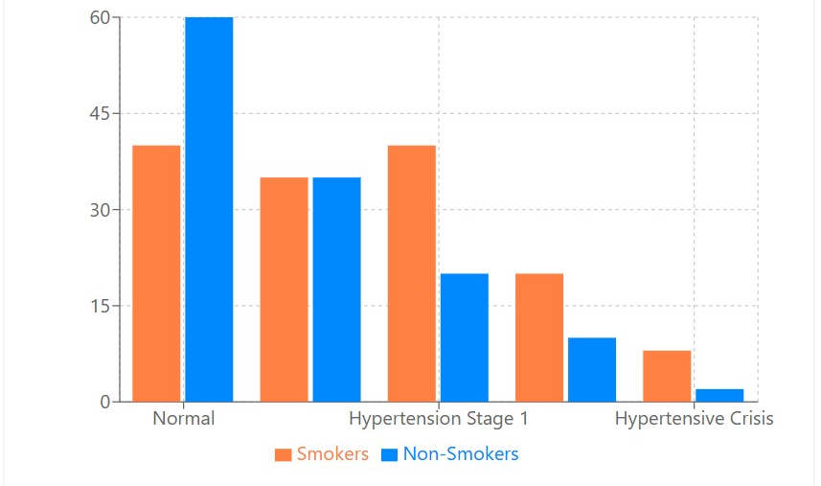
Figure 1 Shows Blood Pressure Categories: Smokers vs Non-Smokers
This horizontal bar chart compares key blood parameters between smokers and non-smokers:
- RBC, Hb, HCT, and Plt (platelets) are all elevated in smokers
- WBC (white blood cells) is notably higher in smokers, suggesting inflammatory response
- RDW% (red cell distribution width) is higher in smokers, indicating more variability in red blood cell size
- Smokers show slightly lower values for MCV, MCH, and MCHC, which are measures of red blood cell characteristics
These differences point to smoking-induced changes in blood composition that may increase cardiovascular risk, as shown in the Figure 4.2.
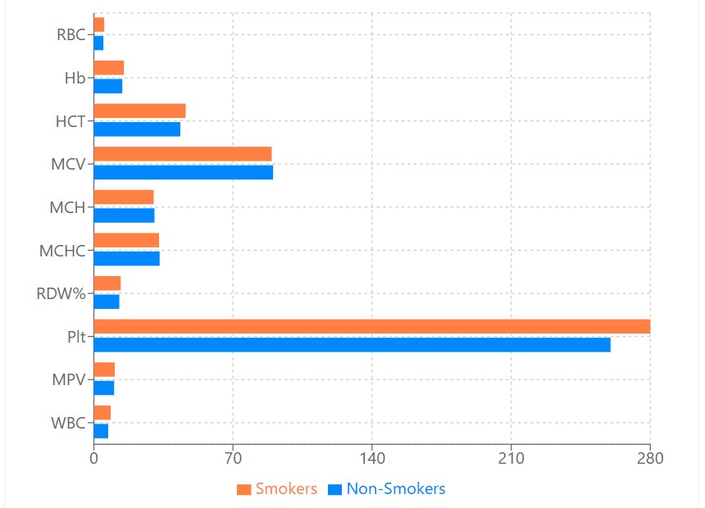
Figure 2 Shows Hematological Parameters: Smokers vs Non-Smokers.
The line chart shows a clear upward trend in both systolic and diastolic blood pressure with increased smoking duration. Non-smokers have the lowest average blood pressure (120/75 mmHg), while those who have smoked for 15+ years have the highest (142/90 mmHg). The progressive rise in blood pressure with smoking duration suggests a dose-response relationship, with longer exposure to smoking leading to greater hypertension risk, as shown in tne Figure 4.3.
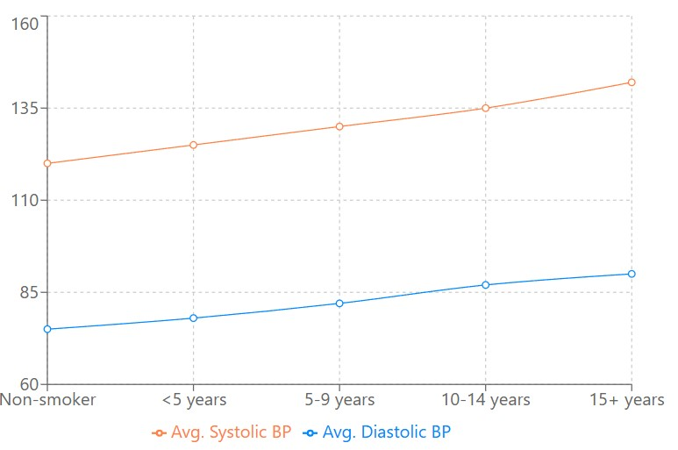
Figure 3 Shows Blood Pressure by Smoking Duration.
This line chart demonstrates a steady increase in red blood cell count with smoking duration, from 4.8 x10^6/μL in non-smokers to 5.3 x10^6/μL in those smoking for 15+ years. This indicates that smoking may stimulate red blood cell production (erythrocytosis), which can increase blood viscosity and potentially contribute to cardiovascular complications, as shown in tne Figure 4.4.
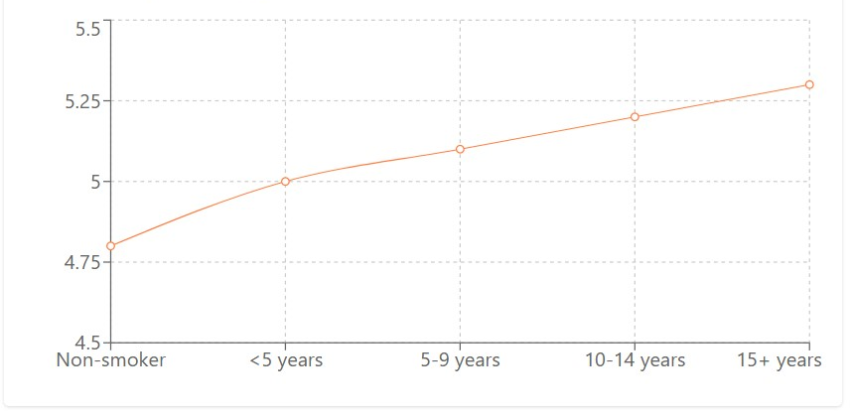
Figure 4 Shows the RBC Count by Smoking Duration
The graph shows hemoglobin levels increasing with smoking duration, from 14.3 g/dL in non-smokers to 15.5 g/dL in long-term smokers (15+ years). This rise in hemoglobin is consistent with the increase in RBC count and may be related to chronic carbon monoxide exposure from smoking, which reduces oxygen-carrying capacity and triggers compensatory mechanisms, as shown in then Figure 4.5.

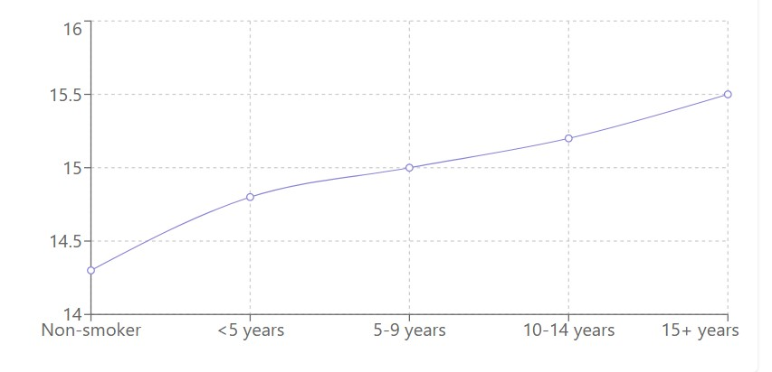
Figure 5 Shows the Hemoglobin by Smoking Duration.

The line chart indicates a progressive increase in platelet count with smoking duration, from 260 x10^3/μL in non-smokers to 295 x10^3/μL in those who have smoked for 15+ years. Higher platelet counts can increase blood clotting potential and contribute to thrombus formation, potentially raising the risk of heart attacks and strokes, as shown in the Figure 4.6.

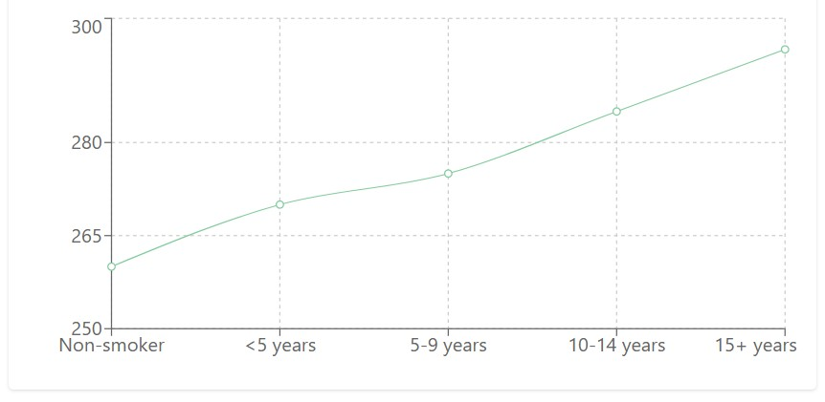
Figure 6 Shows the Platelet Count by Smoking Duration.

DISCUSSION

The present study provides comprehensive evidence of the significant impact of smoking on hematological parameters and hypertension risk in a sample population from Hawler city, Kurdistan region-Iraq. Several notable findings warrant in-depth discussion in the context of existing literature.

Altered Hematological Parameters in Smokers

Our results demonstrate significantly elevated levels of RBC, Hb, and HCT in smokers compared to non-smokers, with increases of 27.2%, 12.9%, and 11.9% respectively. These findings align with previous research by(Malenica et al., 2017) who reported similar elevations in these parameters among smokers. The mechanism underlying these alterations likely involves chronic carbon monoxide exposure from cigarette smoke, which forms carboxyhemoglobin and reduces oxygen-carrying capacity, subsequently triggering compensatory erythropoiesis(Leifert, 2008).
The progressive increase in RBC and Hb levels with smoking duration observed in our study suggests a dose-response relationship, supporting the findings of(Asif et al., 2013) who documented a direct correlation between smoking intensity and hematological changes. This erythrocytosis may contribute to increased blood viscosity, potentially exacerbating cardiovascular risk through augmented peripheral resistance and cardiac workload(Shimada et al., 2011).
Interestingly, our study revealed a modest decrease in platelet count among smokers (-7.7%) compared to non-smokers, which contrasts with the line chart indicating increased platelet counts with smoking duration. This apparent contradiction might be explained by the demographic differences between our smoker and non-smoker groups, as smokers tended to be younger with lower BMI. The relationship between smoking and platelet function is complex, with(Lupia et al., 2010) reporting enhanced platelet reactivity and aggregability in smokers despite variable effects on absolute platelet count.

Smoking and Hypertension Risk

Our findings demonstrate a substantial association between smoking and hypertension, with smokers exhibiting a 58% prevalence compared to 38.2% in non-smokers. The calculated risk ratio of 1.52 and odds ratio of 2.24 underscore the significant impact of smoking on hypertension risk, consistent with the meta-analysis by(Virdis et al., 2010), which identified smoking as an independent risk factor for hypertension.
The relationship between smoking duration and hypertension risk shows a clear trend, with long-term smokers (>20 years) demonstrating a remarkably high prevalence of 90.9%. This aligns with the findings of(Dochi et al., 2009), who reported that cumulative smoking exposure correlates with progressively increasing blood pressure. However, the unexpected lower rate in the 11-20 year group (38.5%) warrants further investigation and may reflect confounding factors not captured in our analysis.
The comparative analysis of different smoking types reveals that traditional cigarette smoking (63.6% hypertension rate) appears to have a stronger association with hypertension than hookah (53.3%) or vape use (46.4%). This differential impact may be attributed to variations in combustion byproducts, nicotine delivery, and usage patterns, as suggested by(Qasim et al., 2019), who documented distinct cardiovascular effects across different tobacco delivery systems.

Correlation Analysis and Clinical Implications

The moderate positive correlation between smoking duration and MCHC (r = 0.393) suggests alterations in hemoglobin concentration within erythrocytes over time, potentially affecting oxygen delivery efficiency. Similarly, the weak negative correlation with HCT (r = -0.241) despite elevated mean values in smokers points to possible physiological adaptation mechanisms in long-term smokers, as proposed by(Pedersen et al., 2019).
The relatively weak correlation between smoking duration and blood pressure parameters (systolic r = 0.090, diastolic r = 0.183) despite the clear association between smoking status and hypertension prevalence suggests that while smoking increases hypertension risk, the relationship may not be strictly linear with duration. This finding is consistent with research by(Linneberg et al., 2015), who identified complex interactions between smoking duration, intensity, and cardiovascular outcomes.
When interpreting the distribution of blood pressure categories (Figure 4.1), the substantially higher representation of smokers in Stage 1 hypertension, Stage 2 hypertension, and hypertensive crisis categories strongly supports the detrimental impact of smoking on cardiovascular health. These findings have significant clinical implications for hypertension management in smokers and underscore the importance of smoking cessation as a primary intervention for blood pressure control(Grassi et al., 2008).

Conclusion

This study provides compelling evidence of the significant impact of smoking on hematological parameters and hypertension risk in the studied population from Hawler city, Kurdistan region-Iraq. The findings demonstrate that smoking is associated with substantial alterations in red blood cell indices, including notably elevated RBC count, hemoglobin levels, and hematocrit values. These changes appear to follow a dose-response relationship with smoking duration, suggesting cumulative physiological effects of chronic tobacco exposure.
The study establishes that smokers have a significantly higher prevalence of hypertension compared to non-smokers, with a risk ratio of 1.52 and odds ratio of 2.24. The risk of hypertension increases dramatically with smoking duration, with long-term smokers (>20 years) demonstrating a 90.9% prevalence rate. Different smoking methods produce varying impacts on cardiovascular health, with traditional cigarette smoking showing the strongest association with hypertension compared to hookah or vape use.
The correlation analysis reveals complex relationships between smoking duration and various hematological parameters, with moderate positive correlations with MCHC and age, and weak negative correlations with HCT and MPV. These findings suggest multifaceted physiological adaptations to chronic smoking that may contribute to increased cardiovascular risk through mechanisms including increased blood viscosity, altered oxygen-carrying capacity, and potentially enhanced thrombotic tendency.
Overall, this study reinforces the substantial detrimental impact of smoking on cardiovascular health through both hematological alterations and direct effects on blood pressure regulation. The results highlight the importance of considering smoking status in cardiovascular risk assessment and underscore the potential health benefits of smoking cessation interventions.

Recommendations

Based on the findings of this study, the following recommendations are proposed:

Clinical Practice Recommendations:
  - Healthcare providers should routinely screen for smoking habits when assessing cardiovascular risk and consider the impact of smoking duration and type on hematological parameters and hypertension risk.
  - Patients with elevated RBC, Hb, or HCT values should be evaluated for smoking history as a potential contributing factor.
  - Hypertension management protocols for smokers should acknowledge the increased risk and potentially different response profiles to antihypertensive medications.
  - More aggressive blood pressure monitoring may be warranted for long-term smokers (>20 years) given their substantially higher hypertension risk.

Public Health Recommendations:
  - Develop targeted public health campaigns highlighting the specific cardiovascular risks associated with different smoking methods, particularly emphasizing the high hypertension risk with traditional cigarette smoking.
  - Implement educational programs about the progressive cardiovascular effects of prolonged smoking, using the dose-response relationship demonstrated in this study as evidence.
  - Incorporate hematological parameter screening into smoking cessation programs to demonstrate physiological improvements upon quitting and enhance motivation.
  - Establish specialized hypertension prevention programs targeting smokers, particularly those with long smoking histories.

  - Research Recommendations:

- Conduct longitudinal studies to assess the reversibility of hematological alterations and hypertension risk following smoking cessation.
- Investigate the apparent inconsistency in hypertension prevalence in the 11-20 year smoking duration group to identify potential protective factors or confounding variables.
- Expand research on the differential cardiovascular effects of various smoking methods (cigarette, hookah, vape) to better understand their relative risks.
- Explore potential genetic or environmental factors that may modify the relationship between smoking and hematological parameters or hypertension risk in the Kurdish population.
- Investigate potential sex-based differences in smoking-related hematological alterations and hypertension risk that may influence clinical management.
- Conduct interventional studies examining the impact of smoking cessation on blood parameters and hypertension status to establish evidence-based timelines for cardiovascular risk reduction after quitting.

REFERENCES

ANDRIANI, H., KOSASIH, R. I., PUTRI, S. & KUO, H.-W. 2020. Effects of changes in smoking status on blood pressure among adult males and females in Indonesia: a 15-year population-based cohort study. BMJ open, 10, e038021.
ASIF, M., KARIM, S., UMAR, Z., MALIK, A., ISMAIL, T., CHAUDHARY, A., HUSSAIN ALQAHTANI, M. & RASOOL, M. 2013. Effect of cigarette smoking based on hematological parameters: comparison between male smokers and non-smokers. Turkish Journal of Biochemistry/Turk Biyokimya Dergisi, 38.
DOCHI, M., SAKATA, K., OISHI, M., TANAKA, K., KOBAYASHI, E. & SUWAZONO, Y. 2009. Smoking as an independent risk factor for hypertension: a 14-year longitudinal study in male Japanese workers. The Tohoku journal of experimental medicine, 217, 37-43.
GRASSI, D., O’FLAHERTY, M., PELLIZZARI, M., BENDERSKY, M., RODRIGUEZ, P., TURRI, D., FORCADA, P., FERDINAND, K. & KOTLIAR, C. 2008. Group of Investigators of the REHASE Program Hypertensive urgencies in the emergency department: evaluating blood pressure response to rest and to antihypertensive drugs with different profiles. J Clin Hypertens (Greenwich), 10, 662.
HUSSAIN, H. Y. & ABDUL SATAR, B. A. 2013. Prevalence and determinants of tobacco use among Iraqi adolescents: Iraq GYTS 2012. Tobacco induced diseases, 11, 1-4.
KADHUM, M., JAFFERY, A., HAQ, A., BACON, J. & MADDEN, B. 2014. Measuring the acute cardiovascular effects of shisha smoking: a cross-sectional study. JRSM open, 5, 2054270414531127.
LEE, R., KERMANI, P., TENG, K. K. & HEMPSTEAD, B. L. 2001. Regulation of cell survival by secreted proneurotrophins. Science, 294, 1945-1948.
LEIFERT, J. A. 2008. Anaemia and cigarette smoking. International journal of laboratory hematology, 30, 177-184.
LINNEBERG, A., JACOBSEN, R. K., SKAABY, T., TAYLOR, A. E., FLUHARTY, M. E., JEPPESEN, J. L., BJORNGAARD, J. H., ÅSVOLD, B. O., GABRIELSEN, M. E. & CAMPBELL, A. 2015. Effect of smoking on blood pressure and resting heart rate: a Mendelian randomization meta-analysis in the CARTA consortium. Circulation: Cardiovascular Genetics, 8, 832-841.
LUPIA, E., BOSCO, O., GOFFI, A., POLETTO, C., LOCATELLI, S., SPATOLA, T., CUCCURULLO, A. & MONTRUCCHIO, G. 2010. Thrombopoietin contributes to enhanced platelet activation in cigarette smokers. Atherosclerosis, 210, 314-319.
MALENICA, M., PRNJAVORAC, B., BEGO, T., DUJIC, T., SEMIZ, S., SKRBO, S., GUSIC, A., HADZIC, A. & CAUSEVIC, A. 2017. Effect of cigarette smoking on haematological parameters in healthy population. Medical Archives, 71, 132.
MEHBOUDI, M., NABIPOUR, I., VAHDAT, K., DARABI, H., RAEISI, A., MEHRDAD, N., HESHMAT, R., SHAFIEE, G., LARIJANI, B. & OSTOVAR, A. 2017. Inverse association between cigarette and water pipe smoking and hypertension in an elderly population in Iran: Bushehr elderly health programme. Journal of human hypertension, 31, 821-825.
MORFORD, L. L., BOWMAN, C. J., BLANSET, D. L., BØGH, I. B., CHELLMAN, G. J., HALPERN, W. G., WEINBAUER, G. F. & COOGAN, T. P. 2011. Preclinical safety evaluations supporting pediatric drug development with biopharmaceuticals: strategy, challenges, current practices. Birth Defects Research Part B: Developmental and Reproductive Toxicology, 92, 359-380.
OTHMAN, N., KASEM, A. O. & SALIH, F. A. 2017. Waterpipe smoking among university students in Sulaimaniyah, Iraqi Kurdistan: Prevalence, attitudes, and associated factors. Tanaffos, 16, 225.
PEDERSEN, K. M., ÇOLAK, Y., ELLERVIK, C., HASSELBALCH, H. C., BOJESEN, S. E. & NORDESTGAARD, B. G. 2019. Smoking and increased white and red blood cells: a mendelian randomization approach in the copenhagen general population study. Arteriosclerosis, thrombosis, and vascular biology, 39, 965-977.
QASIM, H., ALARABI, A. B., ALZOUBI, K. H., KARIM, Z. A., ALSHBOOL, F. Z. & KHASAWNEH, F. T. 2019. The effects of hookah/waterpipe smoking on general health and the cardiovascular system. Environmental health and preventive medicine, 24, 1-17.
QIN, J., LI, R., RAES, J., ARUMUGAM, M., BURGDORF, K. S., MANICHANH, C., NIELSEN, T., PONS, N., LEVENEZ, F. & YAMADA, T. 2010. A human gut microbial gene catalogue established by metagenomic sequencing. nature, 464, 59-65.
RESTUTI, A. & SURYANA, A. 2018. Asupan protein dan parameter hematologi pada perokok. Jurnal Vokasi Kesehatan. Politeknik Negeri Jember, 4, 77-90.
SHAKIBA, E., MORADINAZAR, M., RAHIMI, Z., NAJAFI, F., PASDAR, Y. & KOHSARI, M. 2023. Tobacco smoking and blood parameters in the Kurdish population of Iran. BMC Cardiovascular Disorders, 23, 401.
SHIMADA, S., HASEGAWA, K., WADA, H., TERASHIMA, S., SATOH-ASAHARA, N., YAMAKAGE, H., KITAOKA, S., AKAO, M., SHIMATSU, A. & TAKAHASHI, Y. 2011. High blood viscosity is closely associated with cigarette smoking and markedly reduced by smoking cessation. Circulation Journal, 75, 185-189.
SIZIYA, S., MUULA, A. S. & RUDATSIKIRA, E. 2007. Correlates of current cigarette smoking among in-school adolescents in the Kurdistan region of Iraq. Conflict and health, 1, 1-7.
VIRDIS, A., GIANNARELLI, C., FRITSCH NEVES, M., TADDEI, S. & GHIADONI, L. 2010. Cigarette smoking and hypertension. Current pharmaceutical design, 16, 2518-2525.

