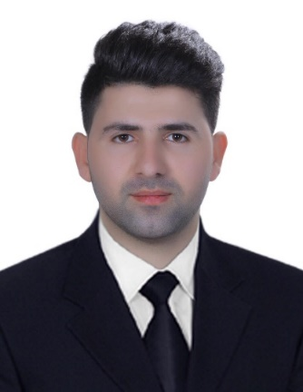
Wzhar Fahri Saadi
Address: Erbil-Pirmam-Zagros st.
Email: wzhar91@gmail.com | Telephone: +964 750 452 3305

Personal Statement I am a confident, caring, assertive and organized person looking for an opportunity to make a real difference into the lives of young students, I have graduated in Poland and I took many communication skills classes to ensure myself how to communicate with students in a best way. My main goal in academic life is to make sure students are supported and encouraged to achieve and obtain their full potential. I do know that it is possible to achieve so in your university with having a convenient environment which you are providing for all students.

Education
2011-2015 Bachelor degree in Cihan University, Iraq
Faculty of Law and diplomacy
Department of international relations and diplomacy

2016-2018 Master degree in Warsaw University, Poland
Faculty of political science and international relations
Department of international relations

Work History Assistant lecturer in Bayan university 2019-2020
Assistant Lecturer in Lebanese French university 2020 – until now

Qualification
- 2016 I have finished English language course in Lazarski University and got B2 certification in the English language
- A member of Exam committee in Lebanese French University in the academic year of (2020 – 2021)
- A member of Academic activity in the department of Diplomacy and International Relations department, in the Lebanese French University
- Member of Academic activity in the college of Law and International Relations in the Lebanese French University
- Member of IT committee in the college of Law and International Relations in the Lebanese French University
Academic research
- Middle Eastern Humanitarian crisis
- The Rise of Globalization and its Effect on The Autonomy of State
- Turkey’s Southeastern Anatolian Project Impact on Iraq’s Water Security
- The New American Isolationism (in the process to be published)
- The Islamic republic of Iran's hegemony in Iraq, the cause, effect, and consequences (in the process to be published)

Skills
- Very good interpersonal and communication skills
- The ability to explain a concept or subject in a variety of ways
- Very good understanding of how students develop and learn
- I have knowledge to use computer especially Microsoft office
- Being patient and understanding at all times and particularly when dealing with learners who have learning difficulties or special needs

Language
Kurdish Excellent in writing, speaking, listening and reading
English Excellent in writing, speaking, listening and reading
Persian Excellent in writing, speaking, listening and reading
Arabic Good in writing, speaking, listening and reading

Hobbies and interests
My hobbies are reading books especially political and historical books and also going to cinema, also spending time with my family and friends. I enjoy meeting with new people, this makes me to think more about working in your university, because every year new students and different people are registering in the University, this is what I am really proud of.

r

