DR. SOHAIL I. KHAN
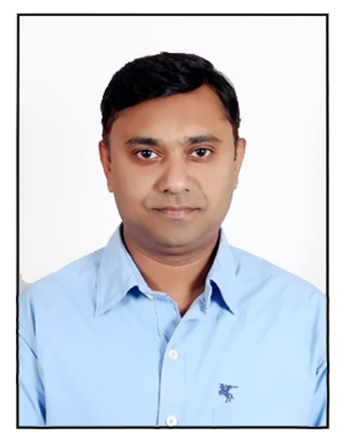
PhD-HR, MBA, M-Com, B-Com, Dip in Comp Engg, MA(Eco)
Contact No’s:+9647507972411 /+919579253318.
Email : sohailkhan@lfu.edu.krd

CAREER OBJECTIVE
To embark my career in a growth oriented institute having visionary approach and apply my best efforts and learn as much as possible.

EDUCATION QUALIFICATIONS
- Ph-D in Human Resource Management from R. T. M. Nagpur University. 2016.
- Pursuing M. A. (Economics) Final Year from R. T. M. Nagpur University.
- M.B.A. in Marketing Management and Human Resource Management from KITS- Ramtek, Dist Nagpur (Maharashtra) 2007-2009.
- M-Com from R. T. M. Nagpur University. Winter 2009
- B-Com from A.G College, Katol Road, R. T. M. Nagpur University, March - 2006.
- Dip. in Computer Engg. from Anjuman Polytechnic, Sadar, Mumbai Board, March 2001.
- H.S.S.C. from S.F.S. College, Nagpur, Maharashtra Board, March -1998
- S.S.C. from St. John’s High School, Nagpur, Maharashtra Board, March – 1996

WORK EXPERIENCE
- Worked with Priyanka Marketing as a Marketing Executive in INDICOM Yellow Pages for about 2 years (Aug 2001 – May 2003).
- Worked as Marketing Executive in Fundoo Infotainment Club at Nagpur for more than 1 year (June 2006 – July 2007).
- Started teaching carrier as a Lecture in Kamla Nehru Mahavidyalaya (MBA & MCA Programme), Nagpur and worked during Aug 2009 – May 10.
- Worked in the capacity of Assistant Professor in Dept. of Management Studies of Kavikulguru Institute of Technology and Science (KITS), Ramtek, Dist: Nagpur for almost 6 years (June 2010- April 2016).
- Worked in the capacity of Head of Department in MBA Department of Tulsiramji Gaikwad-Patil College of Engineering and Technology, Nagpur for about 3 months (June 2016 – September 2016).
- Worked as UGC Approved Assistant Professor in NIT Graduate School of Management, Nagpur (September 2016.- August 2018)
- Presently working as Assistant Professor in the Department of Business Administration in the college of Administration and Economics of Lebanese French University Since Sept 2018.
KEY RESPONSIBILITIES HANDLED
@ Kamla Nehru Mahavidyalaya
- Project Supervisor: Guided 5 students for their dissertation work.
- Faculty In-Charge: Industrial Tour & Visits
- Various Events were organized for the students
@ Kavikulguru Institute of Technology and Science (KITS)
- Faculty In-Charge: Industrial Tour & Visits - Identify and organize field trips to enhance curriculum of student managers.
- Project Supervisor: Guided more than 20 students for their dissertation work.
- Faculty In-charge: Computer Lab.
- Coordinator: Department Examinations.
- Committee Member: R.T.M. Nagpur University Examination.
@ Tulsiramji Gaikwad-Patil College of Engineering and Technology
- Head of the Department
- Head IIPC (Industry Institute Partnership Cell)
- Overall Administration Work
@ NIT Graduate School of Management
- Training and Placement Coordinator/Head Corporate Relations

RESEARCH PUBLICATIONS
- Entrepreneurship, “Role of Entrepreneur in 21st Century in Economic Growth and Development”, Oct 2010, ISSN 93 – 80697 – 84 – 8
- Research Journal, “Strategies of 4Ps for Rural Marketing”, Vol 7. No (1), 2011 -2012, ISSN 0974 – 0317.
- Association of Interdisciplinary Policy Research and Action, “Incredible India: An Education Hub for the World”, ISBN 978 – 81- 926818 – 0 – 1.
- Arthwishva, “A fundamental Analysis of Public Sector Banks in India” Dec 2014, ISSN 2319 – 6289.
- Global Journal for Research Analysis, “Factors Affecting Teachers Job Satisfaction with Special Reference to Ramtek Region”, Vol 4, Issue 02 Feb 2015 ISSN No. 2277 – 8160
- Economics, Management and Sustainability, “The impact of staff training and development on teachers’ productivity”, Vol 4, Issue 1.
- Russian Journal of Agricultural and Socio-Economic Sciences, “The effect of ATM Service Quality on Customer’s Satisfaction and Loyalty: An Empirical Analysis, Vol 4, Issue 89.
- Bulletin of Socail Informatics Theory and Application, “Social media and its adverse effect on academic performance of students, Vol 3, Issue 1.

CONFERENCE/WORKSHOP/FDP’s
Participated and Presented papers on various topics in 7 National Conferences and 6 International Conferences across India.
Attended many Workshop, FDP’s, Training Programs and Seminars during the academic years to enhance my knowledge and skills.

MAJOR ACHIEVEMENT
Won FIRST PRIZE in National Conference in Marketing to the Bottom of Pyramid organized by IBMRD (Institute of Business Management and Rural Development), Ahmednagar (Maharashtra) in March-2010.

IT SKILLS
- Packages :MS-Office, (includes MS-Word, MS-PowerPoint, MS-Excel).
- Language : ‘C’ language.
- Operating System : Windows 2000/XP, and
- Internet Surfing.

CO CURRICULAR ACTIVITIES
- Represented my school in inter school chess competition
- Participated in various Cultural activities at college level.
- Participated in National Level paper presentation Competition.
- Won many Prizes in various events organized by different college in and around Nagpur.

MANAGERIAL SKILLS
- Ability to work under pressure and within prescribed time frame.
- Good Interpersonal skills and adaptability.

HOBBIES
Playing chess, Listening soft music and Travelling.

REFERENCES
- Dr. O. M. Ashtankar (+919422821515)
Ex HoD, Department of Management Studies, KITS Ramtek
Email: omashtankar@gmail.com
- Dr. Mrs. Asha Tiwari (+919422108830)
Associate Professor, LAD College, Shankar Nagar, Nagpur
asha_t2008@rediffmail.com

PERSONAL DETAILS
Date of Birth : 11th January 1980.
Gender : Male.
Nationality : Indian.
Marital Status : Married
Languages Known : English, Hindi, Marathi and Urdu.
Permanent Address : C/O Wakeel Khan,
11/B, Firdous Colony Chowk, Near Baig Hardware,
Shyam Lawn Road, Thakre Layout,
Jafar Nagar. Nagpur – 440013 (Maharashtra) India.
Permanent Phone No : 0712-2580533

DECLARATION
I declare that the above information is true to the best of my knowledge.

Date : - 25/06/2019
Place : - Erbil
DR. SOHAIL IMRAN KHAN

