Shirin Jamal Mohammad Rashid
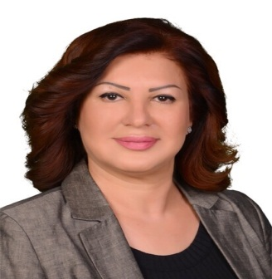

Phone numbers: 00964(0)750 908 22 23
Email:shirin.jamal@lfu.edu.krd
Nationality: Iraqi- Kurds & German
Date & Place of birth: Iraq- Sulimaniya 1965
Marital Status: Married

__________________________________________

Education:
- Teaching Methodology (preparation for PhD & master degree holders to teach in high education) 2019 Lebanese French University/Erbil.
- 2017-2019 Salahaddin University, M.A. (Hons) in Business and Management Science.
- 2010-2014 Cihan University- Erbil, B.A. (Hons) Department of administration- Business Management, grade (91,34)
- 2004-2005 Germany- Diploma in psychological treatments.
- 1986-1978 Erbil- Diploma, Technical Institution Department of Medic.

Competences:
- Highly awareness about political situation of Kurdistan Region, Iraq and overall Middle East.
- Expert and familiar to the each Article of Iraqi federal constitution and the Draft of Kurdistan constitution.
- Have a very good leadership skills and ability of solving problem.
- Able to work autonomously and in a team and work under pressure with quick thinking ability.
- Excellent computer skills in (Word, Excel, Outlook, PowerPoint database management and record keeping.)
- Expert in Management and administration.
- Have a great understanding about psychology and social problem solving.
- Good communication and negotiation skills with realistic analytical.
- Superior interpersonal skills, planning, time management.
- Ability to maintain highly confidential nature of Employment unit work.
- Have a good experience about environment and have a long term plan for the environment in order to save environment and better future (I have my Master degree in Environments fields)
- Cultural flexibility to adapt with different cultures. (having experience to integrate with foreigners in different backgrounds).

Language Abilities:
- Kurdish language Native
- Arabic language excellent (reading, writing, listening and speaking)
- German Language excellent (reading, writing, listening and speaking) German language test 1997-1998 result very good.
- English language very good (IELTS exam 2019 results 5.5 which includes reading, writing, listening and speaking)

Work Experience:
- Assistant lecture and head of department in Lebanese French University Department of health Administration.
- 2001-2008 Working as a German-Kurdish and Arabic vice-versa interpreter and translator.
- 1990-1992 Sulaimanyah Teaching Hospitals as a radiographer.
- 1988-1990 Rzgari Hospital- Erbil as radiographer.
Voluntary Works:
- Voluntary interpreter for many refuges in Germany.
- Participating in introducing different culture’s festival in Germany.
- Participating in collection needs and equipment for Snjar and Bashik IDPs since 2014 until present.
- Work as a volunteer in Barzani Charity Foundation as a (Accountant, helping elderly peoples, helping people with special needs and work as a hospital manager in IDP camps)

